

Structural Design

(Inside View)

**Vertical corrugation**

|  |  |  |  |  |  |  |  |
| --- | --- | --- | --- | --- | --- | --- | --- |
|  |  |  | 26 |  |  |  |  |
| 257*/*16 |  | 41*/*4 |  |  |  |  |  |
|  |  | 69*/*16 | 67*/*16 |  |  |  |  |
|  |  |  |  |  |  |  |
|  |  |  | 139*/*16 |  |  |  |  |
|  |  | 21*/*16 |  |  |  |  |  |
| Cut | Crease | Crease with Matrix | Cut Crease | Half Knife Cut | Tear Tape | Perforation |  |

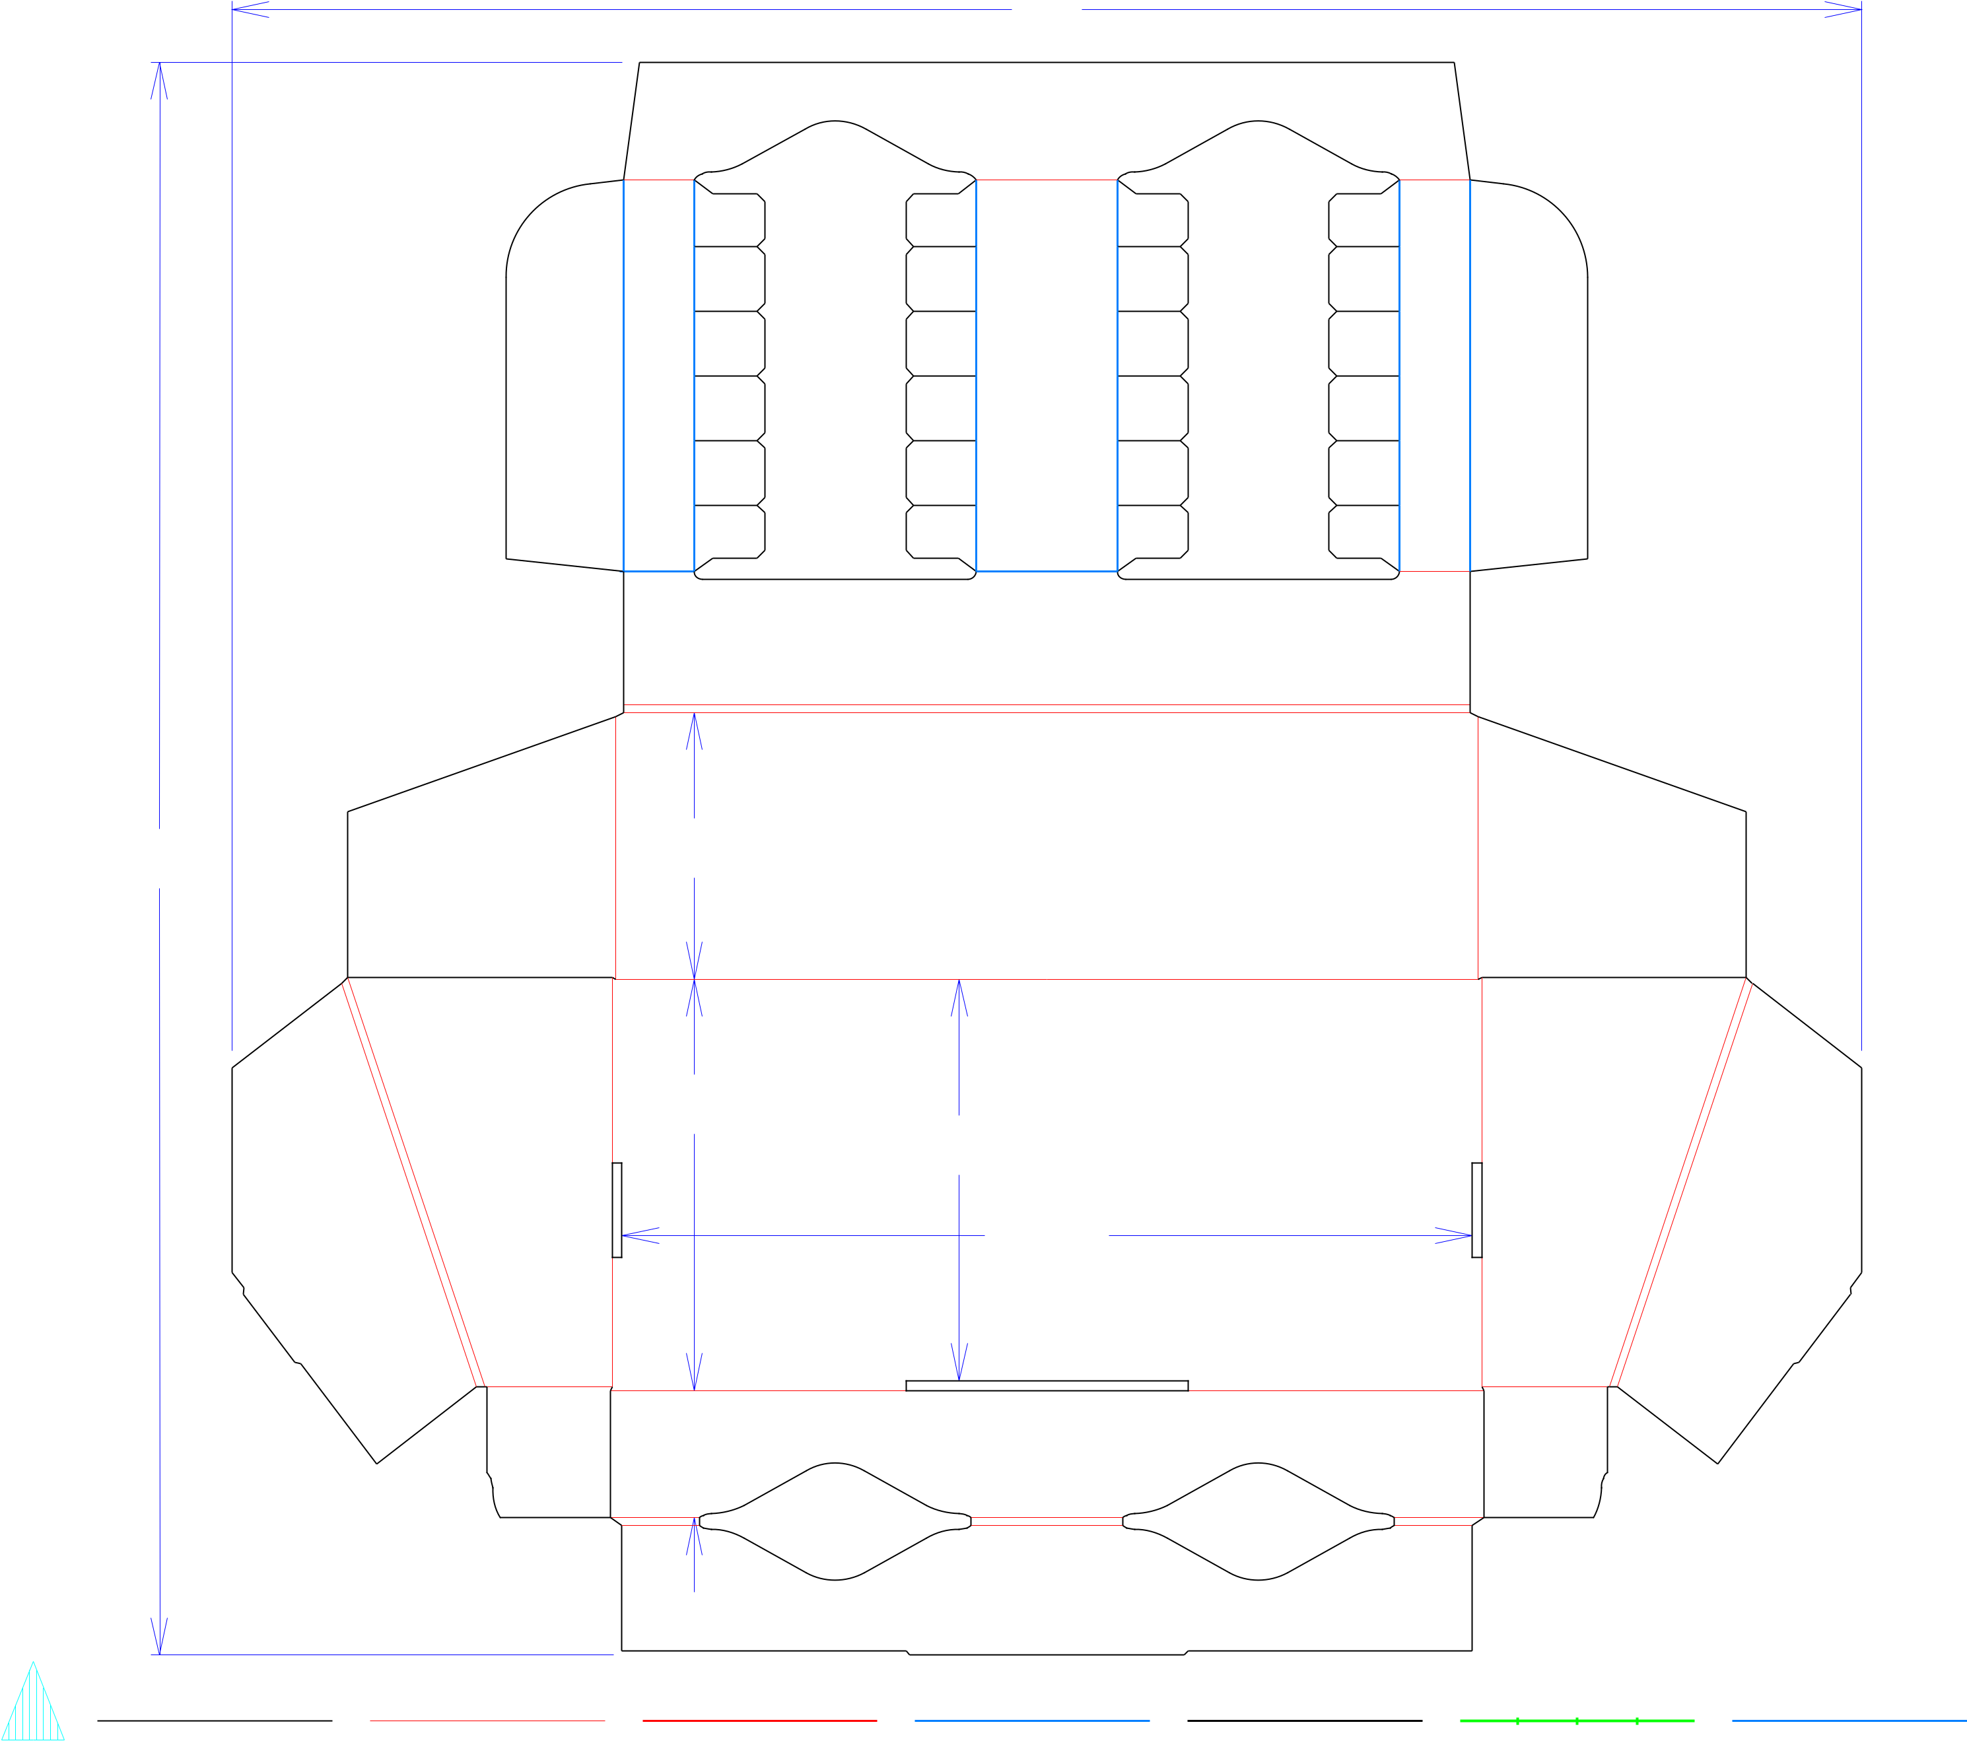

Design#:

**200134-01**

Customer:

**DeMet's Candy**

Description:

**Turtles Try w/HSC- 12ct/2.9oz Heart Boxes**

**SINGLE-OUT DRAWING**

Qty/Unit:

Style: **NJDC**

Board: **32EW**

Combination: **36MW - 23M - 35HP**

I.D. : **13+9/16 x 6+5/16 x 4+9/16**

Area of Blank - Waste : **3.04 sq. ft.**

Waste on Blank : **33.74%**

Finished Piece Weight: **0.34 lbs./155.89g**

Over-all Blank: **25+13/32 x 26**

Approved: Mahenoor Shaikh

Notes:

Revision Info: **[0] 02/19/2020**

Designer: **Amy Kirchhoff**

Designright and Copyright of DS Smith Corrugated Packaging Ltd. This technical Specification is subject to Manufacturing tolerances. Drawing dimensions shown are crease to crease. Date printed: 02/21/2020